Leadership:
Leadership is undertaken at all levels within the school with members of staff leading a range of activities and developments including the Nursery delivering Play on Pedals programme. The Parent Council continue to support the direction of the school by providing valuable input in school decisions on behalf of the interests of the parents and local community.
All staff have worked closely with the management team to promote improvements in learning and teaching to raise attainment of all pupils. All staff are now trained in Digital Literacy.
Self-evaluation is central to the leadership of learning and teaching in our school. Stakeholders including, staff, children and parents have been involved throughout the year in helping to identify areas for future development. We will continue to develop the school through self-evaluation and quality assurance procedures
Improvement priorities for session 2017-2018
This year we will concentrate on the following improvements:

1. Raise attainment in areas of literacy and numeracy across all stages.

2. Develop and implement greater opportunities for parents to engage in and support their child’s learning.

3. Focus on continued development of effective learning and teaching approaches.

Consultation Process:
Pupil Council, Parent Council and Staff were consulted prior to the completion of this report.

Balhousie Primary School
Standards and Quality Report—2016-2017
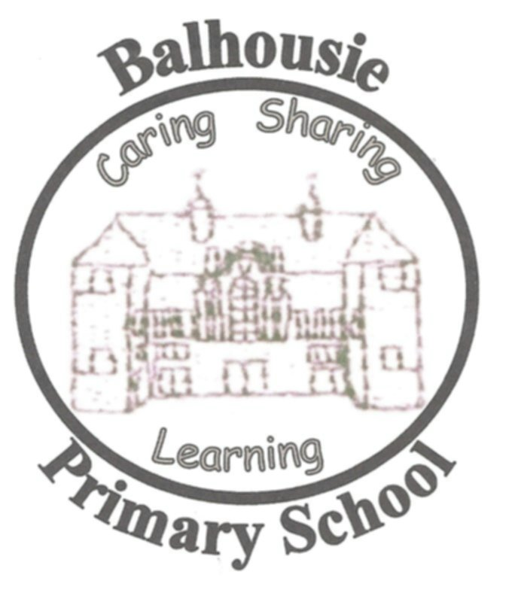

School Vision
Balhousie Primary School encourages everyone to be the best they can be in order to make a valuable contribution to society.
Our vision is of a confident and ambitious school to which all can contribute and in which all can share. Our school will be vibrant and successful; a safe, happy, healthy and sustainable environment; and a place where people are nurtured and supported.
School Values
We encourage everyone to be the best that they can be.
We have mutual trust, self-respect and value everyone's contribution.
We recognise everyone as an individual.

School Aims
Our aims are:
- To create a learning community that develops fulfilled, responsible citizens.
- To provide meaningful contexts for learning that challenge all children, raising standard of attainment.
- To provide children with opportunities to develop self-confidence and resilience.
- To maintain and extend partnerships with home and community.
- To support and meet the learning, personal and social needs of all children and their families.

Our purpose is to:
- To celebrate the uniqueness of Balhousie
- To raise attainment for all pupils
- To increase children and family engagement in learning
- To equip our children to be young work force of tomorrow.

Attainment, Attendance and Progress

In Primary one, almost all children are making very good progress within the Early Level in mathematics, reading and writing, with most being secure at this level.
In Primary four, all children are making very good progress or better at first level across literacy and mathematics with less than half of the children being secure in their learning.
In Primary 7, almost all children are making very good progress or beyond in mathematics with half being secure. In literacy, most pupils are making very good progress with less than half being secure.
Our Strengthening Families programme and Polish dad’s group have been very successful in supporting children and families with English as an additional language. The weekly sessions gave parents an opportunity to speak with the Head Teacher and voice their opinions in an informal environment.

Attendance statistics

The average attendance figure includes non-compulsory nursery attendance. The average attendance figure for Balhousie Primary School for session 2016 – 2017 has increased to 94% from 93% last year.

Learning:

This session the school has invested greatly in Intergenerational work. P5-7 children have been learning through music alongside local care home residents. Skills within these areas have been transferrable, strengthening the children’s engagement in developing the skills required to be a successful contributor to society.
There has been a wide range of extra-curricular opportunities for children this session including skiing, swimming and an outdoor education overnight stay to Dalguise. These have allowed pupils to achieve success in a variety of ways beyond the classroom. The creative and musical talent of the children was further developed in their performance of GLEE production at Perth Concert Hall.
P5/6 have contributed to the development of play in the playground after they engaged in training to become a Mini Play Ranger. All children from P4 –P7 have received Bike Ability Training this session. We are very proud of the sporting achievements of many pupils at County Sports, Netball and Rugby.
Our nursery continues to support children from 2—5years as documented in the recent Care Inspectorate report. As part of the governments Closing the Gap approach word aware strategies are supporting children’s early vocabulary acquisition in Nursery and P1.
In the primary classes, there has been a continued emphasis upon improving the quality of learning experiences, including the use of cooperative learning techniques and children engaging in learning 1+2 language, French. Children had the opportunity during our French café to apply the language skills they have acquired in French. Staff, pupils and parents have also engaged in ongoing learning about and discussion of the SHANARRI wellbeing wheel in relation to children’s life and learning.
Learning has been shared with children and parents during Learning Evenings and afternoons, by newsletters and the school website. Children and staff have are beginning to engage in using ICT to create on line learning profiles similar to those currently used in the Nursery

